CA1 REPORT
Author: Daniel Al-Dzhazzar

- Introduction
This project contains the implementation of database to a website with ability to insert and receive data. Done by Daniel Al-Dzhazzar alone.

- Database structure
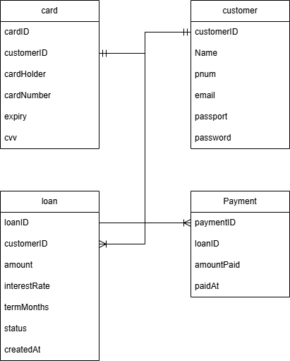

It has 4 tables:
Customer – handles customer and login information
Card – 1 customer can have only 1 card, handles debit cards credentials
Loan – 1 customer can have multiple loans(up to 3 active), consist of loan records
Payment – 1 loan can have multiple payments, saves payments recepts

- User Guide
On first entrance to the website, register a new user by entering all required data in the following fields:
Name must be 3–50 characters long and contain only letters and spaces.
Email must be a valid format (something@something.com), 5–50 characters long and unique.
Phone number must contain 10–13 digits only and be unique.
Passport must follow the format of 2 uppercase letters followed by 6 digits (AB123456) and be unique.
Password must be 8–25 characters long and include at least one uppercase letter, one lowercase letter, and one number.

After registration to login, click on “Have an account already? Enter” and provide your email and password.

After authorization, the following options become available: Take a Loan, Profile, Logout.

Logout ends your current session.

Profile contains your personal data, loans, payment section, and statistics:
Personal section displays your registration data.
Loans section shows all your loans, both active and completed.
Payment section allows you to select a loan and make a payment. Before making a payment, you must add a debit card using the button provided. After adding card details successfully, you can enter a payment amount (greater than 0). The system will also display the percentage of the loan already paid.
Statistics section provides aggregated information about your loans.

Take a Loan allows you to apply for a loan with the following conditions:
Minimum loan amount is 1000 euros.
Loans below 10000 euros have a 5% interest rate and a maximum term of 6 months.
Loans between 10000 and 50000 euros have a 3% interest rate with available terms of 6 or 12 months.
Loans above 50000 euros have a 2% interest rate with available terms of 6, 12, 18, or 24 months.
Info and Contact sections contain information about the company and contact details.

- Modern Research
The project incorporates several practices aligned with modern web development:
- Prepared Statements to prevent SQL injection attacks
- Input Validation
- Transaction Management (ACID) for reliable financial operations
- User Authentication via Cookies

- Work breakdown
This job was done 100% by me on a span of several weeks:
- Week 1: conceptualizing
- Week 2: database structure development
- Week 3: coding
- Week 4: debugging

There was a lot of bug during debugging stage, mostly consisting of data not showing correctly, which was fixed after several hours of work.

- Testing plan
To test I would:
- Create a new user
- Logout
- Login as said user
- Try to take 0 dollar loan
- Try to take 1000 dollar loan
- Try to take a loan from 3 major categories
- Try to take 4th loan while 3 is active
- Check user data display
- Check loan display
- Try to add a card
- Try to pay 0 for a loan
- Try to pay 2 times the total loan amount
- Try to take another loan after I would pay one
- Check statistics after that
- Delete my account

- Conclusion:
The project provide successfully working basic banking system for loans and user authentication.

